Project Report: Predicting Sleep Disorders
Prepared By: Jatin

1. Executive Summary
Sleep disorders, such as Insomnia and Sleep Apnea, are critical health issues that significantly impact quality of life and long-term cardiovascular health. This project successfully developed a machine learning solution to predict these disorders based on lifestyle and demographic data.
After evaluating multiple algorithms, the Random Forest Classifier emerged as the optimal model, achieving an accuracy of 94.7%. The analysis highlighted that BMI Category (Obesity), Blood Pressure, and Sleep Duration are the most significant predictors of sleep disorders. The model provides a reliable tool for early detection and personalized patient care.

2. Project Overview
2.1 Problem Statement
Sleep disorders are often undiagnosed until they cause severe health complications. Traditional diagnosis requires expensive and time-consuming sleep studies. There is a need for a pre-screening tool that utilizes readily available patient data to assess risk.
2.2 Objectives
- To analyze the relationship between lifestyle factors (occupation, physical activity, BMI) and sleep health.
- To develop a multi-class classification model capable of predicting "None", "Insomnia", or "Sleep Apnea".
- To compare the performance of Decision Trees, Random Forests, and Logistic Regression.

3. Data Analysis & Methodology
3.1 Data Source
The dataset consists of 374 records with 13 features, including:
- Demographics: Age, Gender, Occupation.
- Vitals: Blood Pressure, Heart Rate, BMI Category.
- Lifestyle: Physical Activity Level, Stress Level, Daily Steps.
- Sleep Metrics: Sleep Duration, Quality of Sleep.
3.2 Data Preprocessing
To prepare the data for machine learning, the following steps were taken:
- Handling Missing Values: Null values in the Sleep Disorder column were imputed with "None" (indicating no disorder).
- Standardization: Inconsistent labels in BMI Category (e.g., "Normal Weight" vs. "Normal") were merged.
- Feature Engineering: The Blood Pressure column (e.g., "126/83") was split into two separate numerical features: Systolic BP and Diastolic BP.
- Encoding: Categorical variables (Gender, Occupation, BMI) were transformed using One-Hot Encoding.

4. Exploratory Data Analysis (EDA)
Comprehensive visualization revealed several key insights regarding the population's sleep health.
4.1 Disorder Distribution
The dataset is imbalanced but represents three distinct classes: healthy individuals (None), and those suffering from Insomnia o r Sleep Apnea.
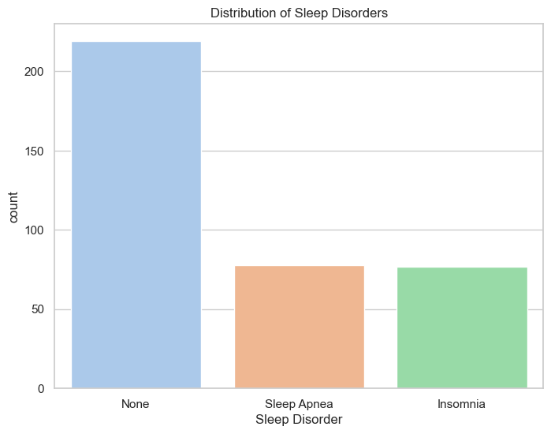

4.2 Key Findings
- Gender Disparity: Females in the dataset show a significantly higher prevalence of Sleep Apnea compared to males, who are generally healthier in this sample.
- The Obesity Link: There is a stark correlation between weight and sleep health. Individuals classified as Obese had a 100% occurrence rate of sleep disorders (either Apnea or Insomnia) in this dataset.
- Occupation Risk:
  - High Risk: Nurses and Sales Representatives show the highest rates of Sleep Apnea.
  - Low Risk: Doctors and Engineers reported the best sleep health.
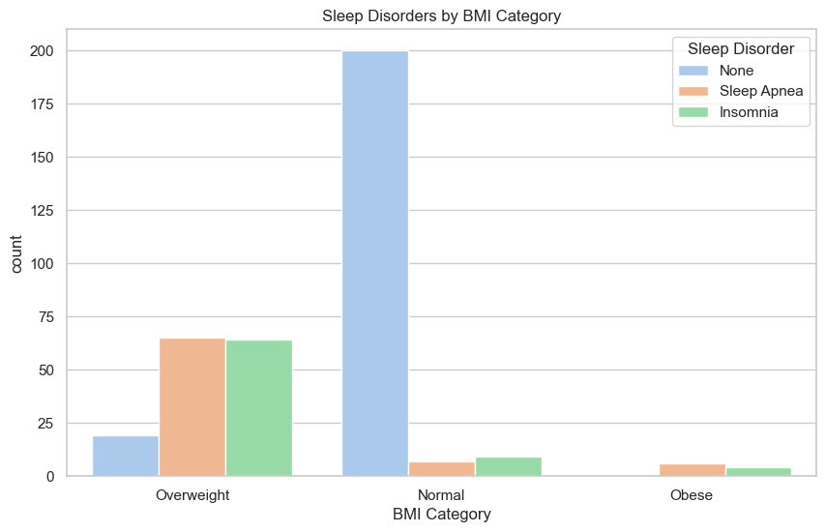
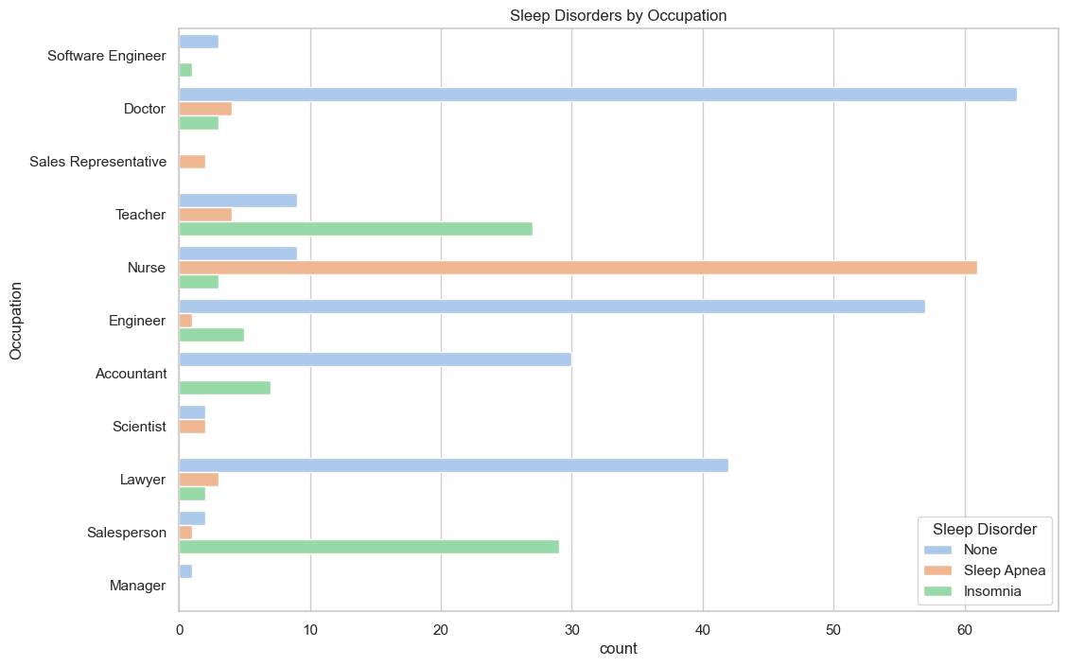
4.3 Correlation Analysis
The correlation heatmap highlights that Stress Level is negatively correlated with Sleep Quality, while Systolic Blood Pressure shows a positive correlation with sleep disorders.
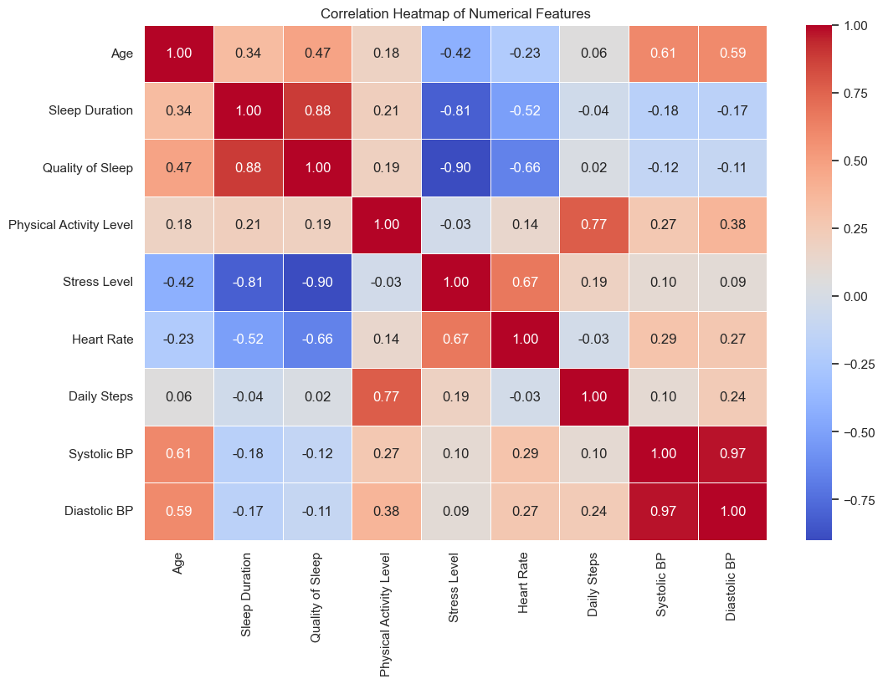
5. Model Development & Evaluation
5.1 Model Selection
We trained and evaluated three supervised learning algorithms:
- Decision Tree Classifier: To capture non-linear decision boundaries.
- Random Forest Classifier: An ensemble method to reduce overfitting and improve accuracy.
- Logistic Regression: A baseline linear model for comparison.
5.2 Performance Metrics
The models were tested on a stratified 20% hold-out test set. The Random Forest model outperformed the others across all metrics.
Model | Accuracy | Precision | Recall | F1-Score
Random Forest | 94.7% | 0.95 | 0.95 | 0.95
Logistic Regression | 93.3% | 0.94 | 0.93 | 0.94
Decision Tree | 92.0% | 0.93 | 0.92 | 0.92
5.3 Feature Importance
Using the Random Forest model, we identified the top 5 factors driving predictions:
- BMI Category (Overweight/Obese)
- Systolic Blood Pressure
- Diastolic Blood Pressure
- Sleep Duration
- Age

6. Conclusion & Recommendations
6.1 Conclusion
The project successfully demonstrated that sleep disorders can be predicted with high accuracy (>94%) using basic health and demographic data. The strong link between BMI, Blood Pressure, and Sleep Apnea suggests that cardiovascular and weight management interventions could significantly improve sleep outcomes.
6.2 Recommendations for Healthcare Providers
- Targeted Screening: Prioritize screening for Nurses and Sales Representatives, as well as any patient with a BMI classified as "Overweight" or "Obese".
- Holistic Approach: Treatment plans for Sleep Apnea should strictly integrate weight management and blood pressure control programs.
- Prevention: Public health campaigns should focus on the correlation between stress reduction and improved sleep quality, as evidenced by the data.

Appendix: Technical Environment
- Language: Python 3.x
- Libraries: Pandas, Scikit-learn, Matplotlib, Seaborn
- Environment: Jupyter Notebook

